**Communication Management Plan Version 1.0**

**Date: May 29, 2021**

**Project Name:** Online Home Food Ordering Application.

1. **Stakeholder communications requirements:**

Communication management's primary goal is to identify the information that needs to communicate with the stakeholders and communicate to them and determine the person responsible for communication at regular intervals. It is used to provide weekly check-in meetings and high-level timeline/budget/progress update via mail. Because this project entails many employees from across the organization, surveys, interviews, checklists, and other tools and procedures will use by the project team to assess the communication requirements for various stakeholders, including outside suppliers.

|  |  |
| --- | --- |
| **Resource** | **Key Project Information** |
| Project Sponsor | Project approvals during the initial phase |
| Project Manager | Project Status &Progress reports throughout project planning |
| Team Lead | Daily meeting minutes, Team schedule during project execution |
| Programmer | Design documents /deliverable |
| QA Lead | Test results and quality reports |

1. **Communications summary:**

The table below describes the various stakeholders, required communications, communication delivery method or format, who will produce the communications, and when or how often they will distribute. All of the project's communications will be stored and made available on the project's website. To improve communications, the project team will employ a variety of templates and checklists.

|  |  |  |  |  |
| --- | --- | --- | --- | --- |
| **Stakeholders** | **Communications Name** | **Delivery Method/Format** | **Responsibility** | **Due/Frequency** |
| Project team | Monthly Project Status Meetings | Report of the status of the project, including activities, progress, costs, and issues | Yaswant Lakkaraju,  Pruthvi Raj Padthe,  Mehal Reddy Mela,  Mohith Vanama,  Roopin Vipparthi. | Monthly |
| Project steering committee | Weekly status report | Hard copy and short meeting | Mohith Vanama. | Weekly  Thursday-10 a.m. |
| Sponsor and champion | Monthly status report | Hard copy and short meeting | Mehal Reddy Mula. | Monthly |
| Development Team | Project announcement | The memo, email, intranet site, Slack, and announcement at department meetings | Mohith Vanama, Pruthvi Raj Padthe, Yaswant Lakkaraju. | May 27, 2021 |
| Project team | Weekly status report | Short meeting | Yaswant Lakkaraju,  Pruthvi Raj Padthe,  Mehal Reddy Mela,  Mohith Vanama,  Roopin Vipparthi. | Weekly  Wednesday-3p.m. |
| Application Engineer Team | Weekly status report | email, intranet site, tools, and announcement at department meetings | Mohith Vanama, Pruthvi Raj Padthe, Yaswant Lakkaraju | Weekly Thursday – 5 pm |

1. **Comments/Guidelines:**

* Make sure people understand the communications. Use commonsense techniques to check comprehension, such as explaining what you are trying to say in your own words.
* Schedule meetings and have a direct conversation, and all documents should be shared only through SharePoint.
* Email is the preferred formal way of communication to convey information.
* Face-to-face conversation for every milestone if possible.
* Official approval/Sign off documentation for every deliverable.
* One should follow a formal procedure for updating a communication management plan.
* Use the titles and dates of documents in email headings and have acknowledged receipt.
* There should be proper reason and approval from the project manager to update the plan.
* The version will update with the update in the plan.
* One should set a feature of automated mail if you are not available for work due to personal reasons and the person's details to be contacted in their absence.

1. **Escalation procedures for resolving issues:**

Escalation procedures are nothing but to differentiate the severity of the problem and provide the appropriate solution to a problem. The flowchart described below shows the flow of the escalation procedure to resolve an issue.

For example, if the person responsible did not respond through the preferred communication channel, one can escalate the issue to upper management.

* If they were no response to a maximum of 3 emails, the client could escalate to senior authority.
* If a team member could not attend the meeting as scheduled, it must be informed as early as possible, leading to escalation.
* If a deliverable is delayed without any prior notice, one can escalate to the program manager.
* If the person in vacation, if there is no backup leads escalation, plan and provide contact details of the backup person to the client.

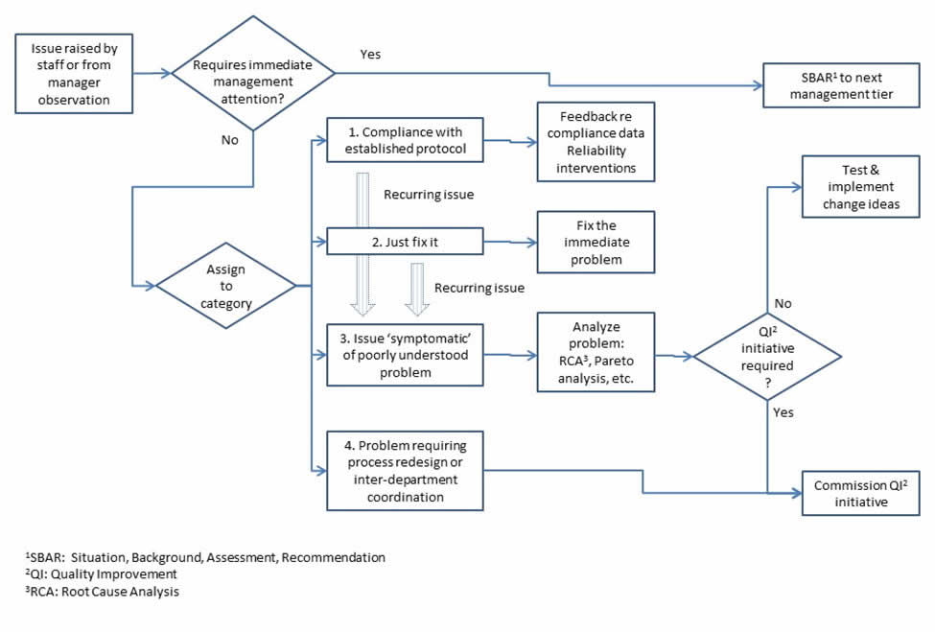

1. **Revision procedures for this document:**

* The project manager will approve the revision to this plan. The revision number and date will be mentioned at the top of the document.
* The project manager would no doubt require making a specific revision to the project schedule and the budgetary and resource requirements of the project.
* These revisions are made, in general, by considering the current status of the project and the advancement that should have made to the project in the time that has elapsed from the day the project has started
* Thus, the project manager has to consider the details of the status reports generated by the sub-team and consider whether any revisions are required or not.
* In case of such a revised plan has to formulate, all stakeholders associated with the project need to be communicated about the changes being made, along with the reasons behind such revisions and the consequences of these revisions

1. **Glossary of common terminology:**

* Virtual team: Group of people works together across time and space boundaries using communication technologies.
* Brainstorming: A technique to foster the group's productivity by encouraging the group members to express their ideas.
* Document Management system: Document Management system provides a platform for organizing all paper and digital documents.
* Daily emails: As needed for the development team to show their progress to the stakeholders.
* SBAR: Situation, Background, Assessment, Recommendation to describe the problem to the next-level manager and recommend a course of action.
* Baseline: The original project plan plus approved changes
* QI: Quality Improvement
* RCA: Root Cause Analysis